**Solution to question # 01**

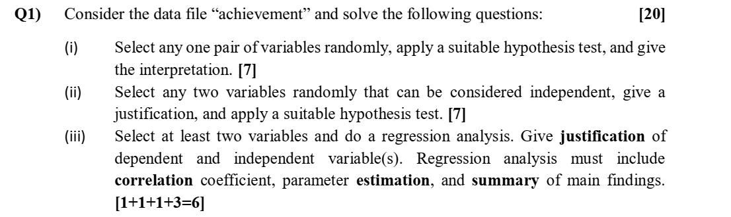

**Solution**

1. There are six paired variables in the achievement file (pre Vs post). The student must select at least one pair (pre Vs post) and apply dependent sample t-test. (**Ho: µpre = µ post**)
2. Student must apply independent sample t-test. Example: Ho: (**µprebody = µ preLet), (µPREFORM = µ PRENUMB), (µpostForm= µ postNumb) etc.**
3. Regression model could be of the form:

**Post = α + β1PreLet + β2PreForm + error**

**PeaBody = α + βAge + error**

**(PostLet – PreLet ) = α + β1Age+ error**

[d = (PostLet – PreLet ) represents a measure of how much the children have gained in their knowledge about letters]

**Summary of main findings:**

* Check the sign of regression coefficients and student’s comments. For example if regression coefficient is positive then there must be reported direct or positive relationship b/w X & Y.
* Coefficient of determination= (correlation^2)*100. If it is greater than 60% then the regression model is good.
* (if student has used software, optional): then there must be a ANOVA table for over significance of regression model, t-statistic and standard error for each coefficient with comments. There must be comments on residuals and outliers.